**Gravitational Wave Data Analysis**

Zachary Cohen, Dechong Wang, John Wright

**Motivation and Introduction**

The recent construction of the LIGO gravitational wave observatory is an exciting development which has enabled astrophysicists to gather experimental data relevant to general relativity and the behavior of black holes. The LIGO observatory detects and gathers data describing gravitational waves which are generated by the merging of black holes (and sometimes other objects). The form of these gravitational waves provides information about the events which generated them. Most straightforwardly, it is possible to use this data to approximate the mass of the black holes which generated the gravitational wave and the distance at which the wave originated. Our goal in this project was to perform those two calculations in order to learn more about gravitational waves.

**Methods**

We used data from the LIGO detectors for gravitational wave GW190521_074359. Before performing any data analysis, we passed the data through a band-pass filter with limits of 50-250Hz in order to remove some noise. We also shifted and inverted the waveforms from one detector because they are spatially separated (and so measure the wave at different times) and also in different orientations. The resulting waveforms are plotted below.

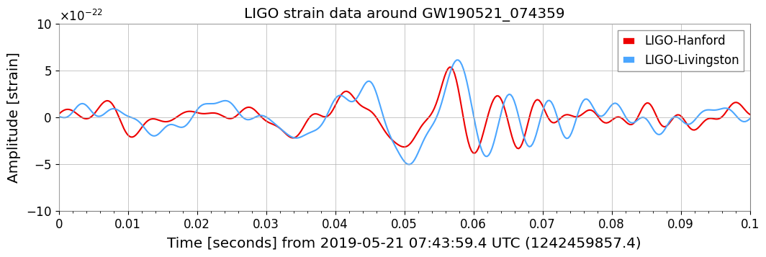

In order to use this data to estimate the mass of the black holes and the distance of the merger event, we use the following methodology.

At the time immediately before merging, the orbital period of the black holes can be approximated directly from the data by finding the period of the gravitational wave $δ_{t}$. The orbital radius at this point will be about twice the Schwarzchild radius $R_{Sch}$. If the black holes are orbiting at velocity $v = \sqrt{GM/2R_{Sch}}$, we will have $δ_{t}=2πR_{Sch}/v$. We have been assuming here that the black holes have the same mass $M$. Using the formula for the Schwarzchild radius $R_{Sch}=2GM/c^{2}$, we are able to solve for $M$ as follows:

$M=\frac{δ_{t}c^{3}}{16πG}$

The amplitude of the gravitational wave decays hyperbolically with distance traveled, allowing us to say $D=\frac{R_{Sch}}{h}$ where $D$ is the distance at which the event occurred and $h$ is the amplitude of the wave in the above figure. Using the formulae we have for $R_{Sch}$ and $M$, this simplifies to

$D=\frac{δ_{t}c}{16πh}$.

We calculated both $δ_{t}$ and $h$ from the LIGO data and then used those equations to find our estimates.

Finally, we estimate the energy released during the merger. This is approximately 10% of the estimated mass [2].

**Results**

We used the values $δ_{t}=1.4⋅10^{-2}s$ and $h=5.4⋅10^{-22}$. This gave us the estimates $M=57$ solar masses and $D=1.6⋅10^{10}$ lightyears (approximately 5000 Mpc). This implies an estimate of 5.7 solar masses of energy released.

**Conclusions**

Our findings differ significantly from the results published in the LIGO database, which have masses of 43 and 33 solar masses[1] and approximately 1000 Mpc distance. This difference is easily explained by the fact that we made a number of simplifying assumptions and the presence of ambiguity about the best way to estimate $δ_{t}$ from the data. It is nevertheless impressive that we are able to estimate the correct results to within an order of magnitude in this way.

**References**

[1] <https://gwosc.org/eventapi/html/allevents/?pagesize=all>

[2]<https://www.forbes.com/sites/startswithabang/2021/05/05/why-28--47--72-not-75-for-black-holes/>

**Contribution Statement**

Zachary Cohen wrote the original draft of the Motivation and Contribution Statements, John Wright wrote the Methods and Results sections and revised and compiled all sections, and Dechong Wang wrote the original draft of the Conclusion and the AI statement.

**AI Statement**

AI tools were not used in the creation of this report.

1. This corrects an erroneous statement from our in-class presentation which resulted from a confusion between GW190521_074359 and GW190521.